RHYDHM Physio & Fitness Center

Dr. Neha Sharma (PT)
Qualification
BPT, MPT
IAFT, COMT
Designation
Senior Physiotherapist & Osteopath

Registration
Reg. MIAP – L40798
Reg. No. IAFTDL1000
UPSMF – 3900

Experience
Ex – Ordnance Factory Hospital, Muradnagar
Ex – NTPC Hospital, Dadri
Ex – MohanSwoop Hospital, Dadri
Ex – Dhanwantri Hospital, NTPC Rihand

Contact
📞 9760421410
📞 9411692044
⏰ Clinic Time
4 PM – 8 PM
📲 WhatsApp Appointment Available

Address
H.No. 114, Gali No. 6
New Defence Colony, Near Shiv Mandir
Muradnagar, Ghaziabad – 201206

Specialized Services
• Osteopathy
• Dry Needling
• Advanced Cupping Therapy
• Chiropractic Care
• Sports Rehabilitation
• Manual Therapy
• Pre & Post Rehabilitation Programs

Additional Services
🏠 Home Physiotherapy Available

QR Codes (Redesign Layout)
1️⃣ WhatsApp Contact QR
→ Scan to Save Number
2️⃣ Google Maps QR
→ Clinic Location
3️⃣ Facebook QR
→ Follow Page

→ Scan & Give Review
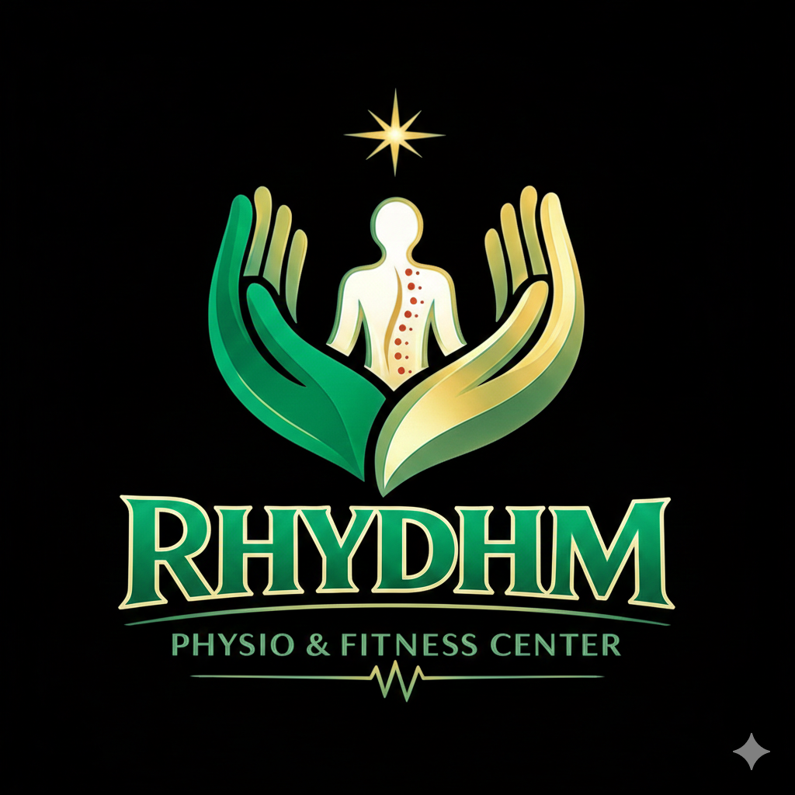



Google review
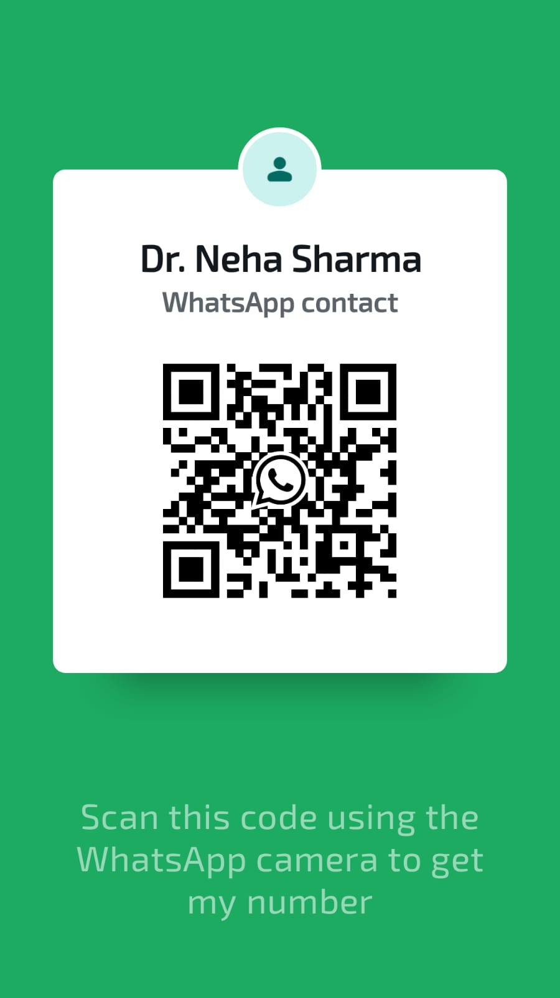


Goggle location

1️⃣ WhatsApp QR
→ नंबर: 9760421410 / 9411692044
बाकी 3 के लिए लिंक चाहिए:
2️⃣ Google Maps Location QR
→ आपका clinic का Google Maps link
3️⃣ Facebook Page QR
→ Facebook page link
4️⃣ Google Review QR
→ Google Business review link
📩 बस ये 3 link भेज दीजिए:
- Google Maps link
- Facebook page link
- Google review link

